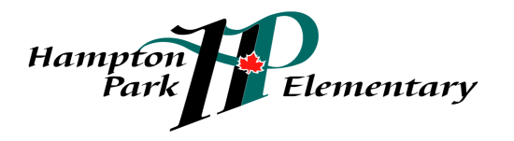 “Safety, Pride, Achievement, Respect, Kindness”
1760 Paddock Drive, Coquitlam, BC, V3E 3N8 Phone: 604-464-2549 Fax: 604-464-2571

Dear Parents,

To continue enhancing our study in the Fine Arts curriculum we are pleased to announce that Hampton Park Elementary is offering afterschool art classes with our Art Program Instructor Cristina Nordin. Students will have additional opportunities to create and continue to expand their artistic talents during afterschool art workshops.
Afterschool Art Workshops will be offered on Fridays
From 3pm-4pm
Cost per student including workshops and art supplies is $75.00
Art Workshops run for 8 weeks on the following Fridays:
February 6th, and 13th
March 6th and March 27th
April 10th
May 1st and May 8th and May 29th
Limited space of up to 10 students is available so book early by completing the form and returning it to the school office.
During our Friday’s workshops students will learn about basics of drawing and painting, how to use a color chart, what a canvas is made out of, mixing paints, shading and texturing as well as applying those techniques to canvas. We will explore history of art, famous artists and discuss and reflect on the art pieces we create. The art workshops are a great addition to our art classes during school time especially for those students who would like to further explore and practice their artistic aptitudes in drawing and painting.

Noteworthy: Painting improves and raises the levels of personal happiness
Strengthens positive attitude; soothes and calms
Helps you think critically and analytically
Brings smiles to our face which helps keep our brain healthy and strong
Helps relief stress and keeps vision healthy and strong
Painting gives meaning and purpose to one’s life and positively fosters communication between all ages
Sharing or offering your artistic talent with someone is the greatest gift you can give
Thank you for your continued support. We know this is a valuable learning experience for students at Hampton Park Elementary.

_________________________________________________________________________________________________
I would like my child _________________________to participate in the afterschool art workshops.
I have included $___________ for the cost of the art workshops and all art supplies.
Medical Concerns (if any) ___________________________________________________________
Parent/Guardian Signature ___________Phone Number_______________ Date________________

